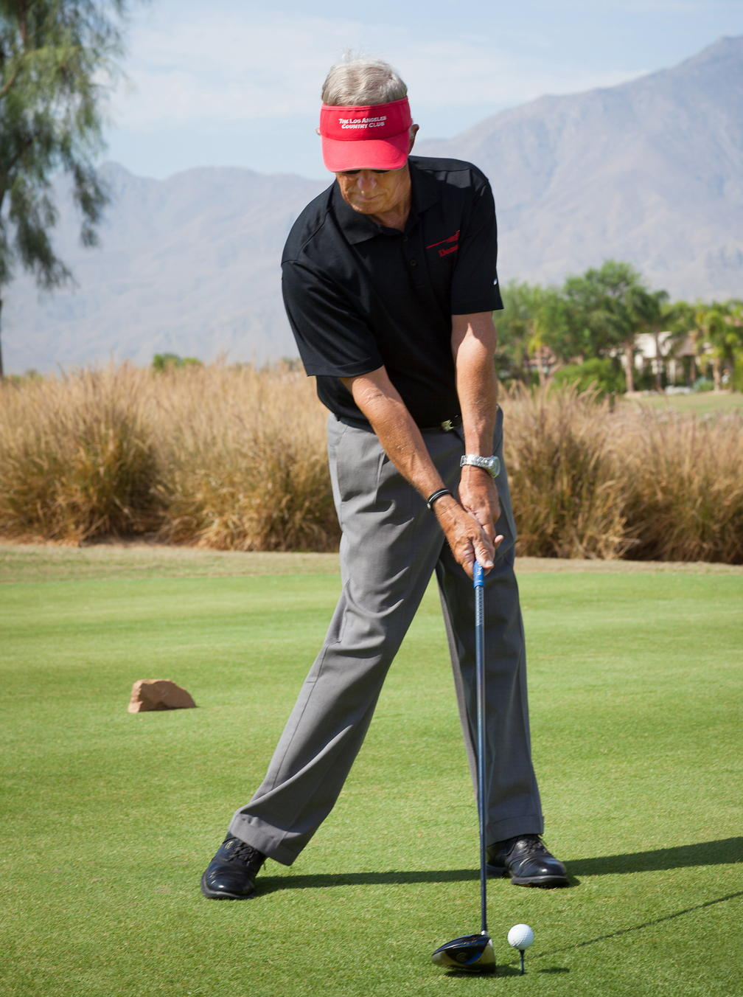
The Zone Golf Academy
Info@ZoneGolf.com
(951) 200-9880
ZoneGolf.com

Swing Change Considerations
If you choose to not make a swing change: you are stuck with your current swing for better or worse, the same inconsistencies, an increasing handicap, a fun factor that will decrease, etc. All of these conditions will be exacerbated with aging.
If that is the path you choose (and 90% of the golfers do choose that path), then that is fine. But be prepared for the above conditions to continue plus you will need to develop an increased sense of humor.
If you decide to make a swing change, then you need a strong mental game to deal with that undertaking and the associated effort. A swing change is mostly a mental effort as you do the technique reprogramming. It requires a significant amount of time and effort.
"Remember that the pain of proper preparation is not close to the agony of regret" - Dr. Joe Parent.
Swing Change Truisms
- There are NO quick fixes, NO magical band-aids, NO magic potions, NO overnight improvements, ...
- Swing change requires time/effort, purposeful practice, constant/pure feedback, and regular master instruction.
- To facilitate a significant swing change you will need master swing and mental game instructors.
- How to find a master swing instructor? Master instructors: always use video every time, have a primary goal of building your confidence, apply a system that will allow you to eventually teach yourself, if not certified to teach the mental should have a strong mental game background, a proven track record in learning/teaching/retaining theory, have a lineage of PGA Tour- level mentors, and a minimum of 1-hour per lesson. Remember being a PGA member merely means that they have been through a dated, general program that included just 10% in the area of instruction.
- Improvements will not be seen in scores nor in the ball flight dynamics for months. But a trained eye can show you improvements in your swing components using video.
- The Tour Pros always take time off from playing when making a swing change.
- If you choose to change your swing and play the course during that process, be prepared for: frustration, anger, shooting a million, a feeling of out of control, a slow-track of improvement, and more annoying events.
- The required and key activity in a swing change is regular, purposeful practice with constant feedback. Are you doing the new movement in practice? The ball flight most likely won't answer that question. The answer comes from regular video and/or a set of trained eyes.
- How much time is required for a swing change? If you are a higher handicap, you will need more time than an accomplished player since you need to get an understanding what the model swing looks like in detail. Without that knowledge, you will never be able to teach/correct yourself which is the goal of a master instructor. Without that knowledge, it like going out to shoot baskets without a hoop! The actual motor skill change will take at least 28 days of purposeful practice- best case.
- The amount of effort and time is significant depending on the level of the golfer. Nick Price, even after being a PGA Tour winner, took months to make the changes required to run Major Championships- this including hitting 800 balls during just one drill plus the other practice that he did. Our bodies cannot do that sort of thing. The ZGA has a fast-track and less painful method (customized for people 55+ years young) to improve your swing.
- Nick Price has an excellent book describing his journey through building/changing a swing. The first chapter is about 27 pages on Perseverance! Very telling.
- In general, several books quote Dr. Erickson that it takes 10,000 hours of purposeful practice to go from a beginner to elite performer in tennis, golf, art, guitar, ... The purposeful practice is so intense that the performer can only do 1,000 hours a year resulting in 10 years to become an elite performer. Since you only want to shave a few strokes off of your score, we can obviously scale down the 10k hours required to get to a +6 handicap of a Tour Pro. And if you are an accomplished player you might already have a few thousand hours in. The point here is that a swing change takes time and effort.
Swing Improvement Components

- Initial Conditions – Grip, Alignment, Posture
- Body Rotation
Posture
Separation of Upper Body and Lower Body
Lower Body
Upper Body- Shoulder Functioning
Head Rotation
3. Timing/Sequencing
4. Impact Position
Pre-Impact
Post-Impact
5. Swing Plane/Path
6. Forearm Rotation
7. Swing Width
8. Shoulder Tilt
9. Elbow Work
10. At the Top
11. Transition
12. Follow-Through Pose

Note: To evaluate progress in the improvement process, the golfer can use the litmus test (or report card) of: (1) assigning a grade (A-F) to the above components and (2) demonstrate (and maybe video) a extra, extra slow motion swing without a ball.

Swing Change (or Motor Skill Learning) Theory
This section is optional reading, and it is included here for completeness plus where to go for more details on learning theory. Much of this section comes directly from the PGA Program that I was in for 6 years.
Learning is not enough as the student needs to apply the knowledge and then retain it in memory and practice.
The classic learning model is the Fitts and Posner 'Three-Phase Model". The three phases are:
1. The Early, Cognitive (Conscious) Phase
This first stage includes conscious thinking about the details of the new movement. The main goal is to understand the concepts of how to perform the new skill. During this phase, the performance is full of errors and timing lacks consistency and accuracy. The learner may observe and know that something is wrong bust does not understand why it is wrong or what needs to be done in order to improve.
The learning of new golf skills might be a matter of transferring previously acquired motor programs, movement patterns, and skill to new skills to be learned. During this phase, the students must consciously think about how to execute and control their movements. Just like your first experience driving a car.
Many errors occur in this early phase as the new motor program contains errors from an unclear understanding and is underdeveloped. In an attempt to gain accuracy during the golf swing, a student may erroneously co-contract muscles around multiple joints in an attempt to fix joint angles and similar action producing errors in performance.
A new skill is not created in the first attempt. It must be attempted many times and feedback will provide direction in the skill development.
The duration of this phase depends on the student's motivation/commitment, their previous similar skills, the complexity of the new skill, quality/quantity of purposeful practice, use of video, quality of instruction, and adequate feedback.
2. The Intermediate (Associative) Phase where there is Conscious Incompetence
This intermediate phase is driven by conscious learning and a level of incompetence in the skill with errors and confusion causing frustration, anger, low confidence, and panic that in turn causes more errors.
With proper practice, this phase will slowly generate fewer error, the tempo becomes more consistent, and the gross errors start to decrease along with the frustration and anger.
Learning is improved by increasing with the amount of purposeful practice until the new motor skill becomes strongly established in memory and the old programming fades away.
As the amount of purposeful practice increases, students gradually learn to allow the muscles around the joints to be controlled independently or incorporated into larger functional units of action. The student's swing look less robotic and stiff, and more fluid and coordinated.
If there was such a thing as 'muscle memory', it would be myelin. Myelin is white cloudy matter that is wrapped around the joints and is produced from hours of purposeful practice.
Obstacles to the learning are: low confidence, active inner critic, fear of failure, and doubt. The last part of this intermediate phase is to transfer the learned skills to the golf course.
The duration of this phase depends on the student's motivation/commitment, their previous similar skills, the complexity of the new skill, quality/quantity of purposeful practice, use of video, quality of instruction, and adequate feedback.
3. The Advanced, Autopilot, Subconscious Phase.
It is during this phase that the student, after high quality practice over a number of weeks or months, begins to control the execution of the skill subconsciously as a habit. And imprints that habit into memory.

The golfer is not consciously thinking about the movement skill during performing on the course. Confidence in performing the skill increases and the fears vaporize. With proper management of potential distractions and a focused, relaxed state: the golfer enters the Zone with the autopilot in charge.

The duration of this phase is driven by maintenance of this Zone state and depends on the student's motivation/commitment, their previous similar skills, the complexity of the new skill, quality/quantity of purposeful practice, use of video, quality of instruction, and adequate feedback.

