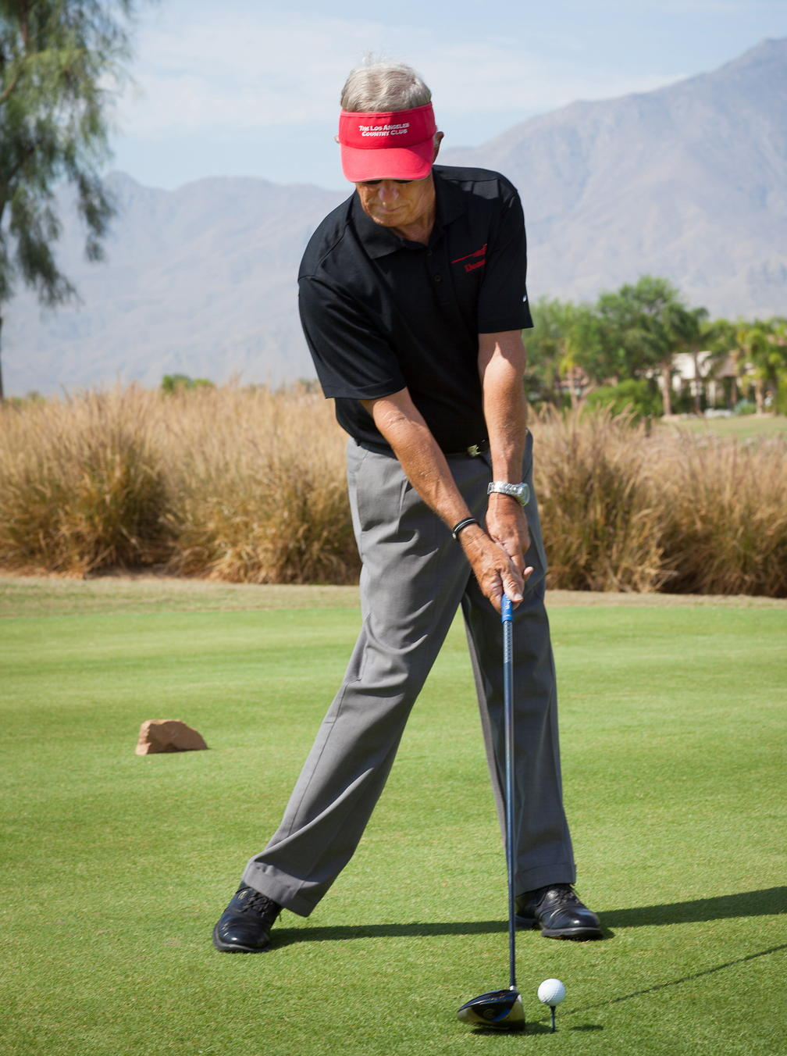

The Zone Golf Academy
Info@ZoneGolf.com
(951) 200-9880
ZoneGolf.com

Choices
Dr. William James, a psychology pioneer, states that we are given a gift of free-will that allows us to control our thoughts therefore allowing us to make choices that either lead to success or not. Thus we really control the destiny of our personality, attitude, and personal attributes. In short, we can control thought-based concepts and therefore our destiny.
Dr. James further states that “people tend to become what they think about themselves. ” You are the biggest influence in your own destiny. You have the power to choose a self-image that will likely determine what you become in life. He maintains that you become what you think about yourself.
Bob Rotella, the ‘father of the golf mental game approach’, mentions free-will in each of his golf performance improvement books. Rotella maintains that free-will drives the two-pronged approach to successful golf improvement: work on the needed physical skills and work on your mental game with emphasis on confidence, perseverance, commitment, motivation, resiliency, mental clarity, and other thought-based concepts.
In Rotella’s recent book, “How Champions Think”, he identifies the proper choices that all successful golfer’s make. ZoneGolfAcademy.com has LeesNotes of this book.
(Take a few minutes right now to ponder the power of free-will and its impact on most aspects of your life.)
We make hundreds or thousands of choices each day. And each choice has a consequence. We can select the choice that has positive consequence or a negative consequence.
Most of the choices are decided by means of habits driven by the subconscious mind (aka the autopilot). Our conscious mind does not have time to decide on the thousands of choices we need to make each day. For example, there are a myriad of choices involved in driving a car, playing a musical instrument, tying our shoes, eating, and on and on. These are performed as a habit developed in the subconscious. And each choice has a consequence. We can select the choice that has a positive consequence.
The choices made by the subconscious are essentially prior programming from the conscious mind over months and years- thus forming a habit. If the choices from a habit are not leading to a positive outcome, we must take over control of the subconscious habit and reprogram the habit with proper choices leading to a positive/successful outcome.
Our personal attributes or traits are thought-based and therefore under our control via choices. We can choose to be:
– Optimistic or pessimistic
– Positive or negative
– Committed or not committed
– Fearless or fearful
– Nervous or calm
– Driven or lazy
– Determined or not determined
– Judgmental or non-judgmental
– Aware or not aware
– Mindful or mindless
– Mentally clear or mentally cluttered/distracted
– Motivated or not motivated
– Happy or sad
– Not angry or angry
– Not embarrassed or embarrassed
– Trusting or not trusting
It is easy to understand how proper choices and free-will can lead to success. Getting into the performance Zone requires the proper choices of the above personal attributes.
As for your golf mechanics, you have some important choices to make:
– Follow a proven blueprint to success or ‘fly blind’
– Use a master instructor or ‘fly it on your own’
– Use a golf psychology expert or not
– Use a proper grip/alignment/stance or not
– Keep the club on plane or wave it like a flag
– Hit the ball with a square clubface or not
– Swing with a smooth tempo or Zorro signing his name
– Hit the 11 proper positions in the swing or not
– Get the club semi-laid off at the top or not
– Use a proper weight shift or not
– Keep a least one back pocket on the ‘backwall’ on the downswing or not
– And on and on
It is interesting to realize that we can essentially choose to have a proper swing by making the proper choices via free-will.
You might be saying ”I want to swing properly but I still resemble Zorro or a person that has just been tasered.” That mindset is understandable, but there is a reason for those thoughts. The reason is that you are swinging the club as you perceive to be correct from old habits, golf channel, another person’s swing, natural instinct, and/or other sources.
You might be choosing to swing like Zorro. To help with your choices/decision, you must acquire the knowledge base of how the elite golfers swing so you can apply new concepts into your swing and remove improper movements. If you are saying “I am pretty sure what the swing should look like”, then here is a litmus test: make a golf swing as slow as humanely possible and have somebody video it.
Actually improving your swing is not in the scope of this chapter. You need to get the help of a master instructor to provide you with a proven blueprint.

